Министерство образования Республики Беларусь
Учреждение образования
«Белорусский государственный университет
информатики и радиоэлектроники»

Факультет компьютерных систем и сетей
Кафедра информатики

КОНТРОЛЬНАЯ РАБОТА ПО ДИСЦИПЛИНЕ
«ИЗБРАННЫЕ ГЛАВЫ ИНФОРМАТИКИ»

Вариант №2

Выполнил: Борисевич А. Ю.
студент группы 353551
(зачётная книжка № 35355001)

Минск, 2026

Задание 2
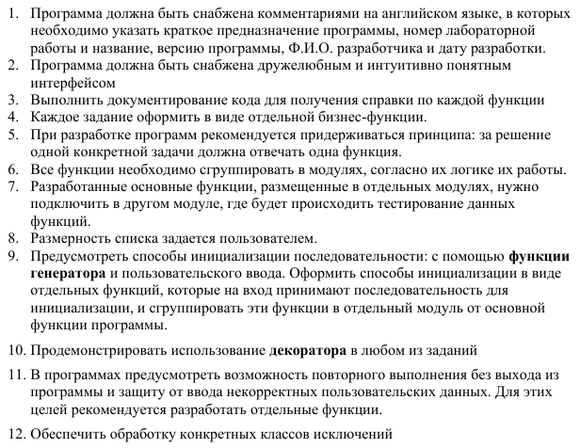
2А)
Не использовать регулярные выражения. В соответствии с заданием своего варианта
составить программу для анализа текста, вводимого с клавиатуры.
Условие: Определить, является ли введённая с клавиатуры строка двоичным числом.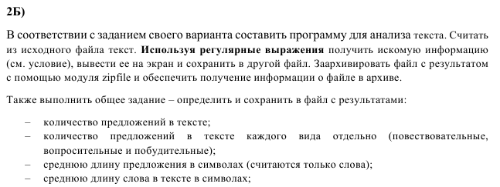
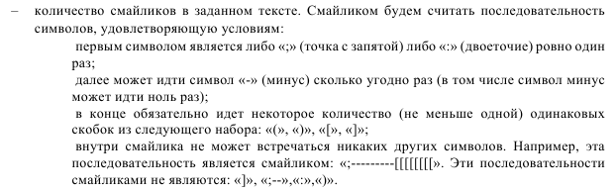
Условие:
- Получить список всех слов текста, не включая пробелы
- В заданной строке все пары символов, первый из которых – малая латинская буква, а
- второй – большая латинская буква, выделить знаками «_?_» с обеих сторон.
- определить число слов, длина которых меньше 7 символов;
- найти самое короткое слово, заканчивающееся на букву 'a';
- вывести все слова в порядке убывания их длин

Результаты работы:
Код:
//main.py

"""
Module: main
Description: Main entry point with menu, task selection, and testing.
Version: 1.0
Author: Borisevich Alexei
Date: 2026-07-02
Lab: Laboratory Work No. 2
Title: Text Analysis and Binary String Validation
"""

import sys
import os
from init_data import init_from_input, init_from_generator, binary_generator
from task2a import is_binary_string
from task2b import read_text_from_file, analyze_text_full, save_results_to_file, archive_file
from utils import safe_int_input, safe_nonempty_input, log_execution

@log_execution
def task2a_interactive():
"""Interactive part for Task 2A: check multiple strings for binary validity."""
print("\n=== TASK 2A: Binary String Check ===")
print("How many strings do you want to test?")
count = safe_int_input("Count: ", min_val=1)
print("Choose initialization method:")
print("1. Manual input")
print("2. Generator (simple binary examples)")
method = safe_int_input("Choice (1 or 2): ", min_val=1, max_val=2)

if method == 1:
strings = init_from_input(count, "Enter string: ")
else:
strings = init_from_generator(count, binary_generator)

print("\nResults:")
for idx, s in enumerate(strings, 1):
result = "Yes" if is_binary_string(s) else "No"
print(f"{idx}. '{s}' -> binary? {result}")

@log_execution
def task2b_interactive():
"""Interactive part for Task 2B: read from file, analyze, save, archive."""
print("\n=== TASK 2B: Text Analysis ===")
# Get source file (existing)
while True:
source_file = safe_nonempty_input("Enter path to source text file: ")
if os.path.isfile(source_file):
break
print(f"File '{source_file}' not found. Please provide an existing file.")
try:
text = read_text_from_file(source_file)
except Exception as e:
print(f"Failed to read file: {e}")
return

# Perform analysis
results = analyze_text_full(text)

# Display results on screen
print("\n--- ANALYSIS RESULTS ---")
print("Sentence statistics:")
for k, v in results['sentence_stats'].items():
print(f" {k}: {v}")
print(f"Smiley count: {results['smiley_count']}")
print("\nSpecial processing:")
sp = results['special']
print(f" Words shorter than 7 chars: {sp['short_words_count']}")
print(f" Shortest word ending with 'a': {sp['shortest_word_ending_a']}")
print(" Words sorted by length (descending):")
print(" " + ", ".join(sp['words_sorted_desc_length'][:20]) + ("..." if len(sp['words_sorted_desc_length']) > 20 else ""))
print("\nHighlighted text (first 500 chars):")
print(sp['highlighted_text'][:500] + ("..." if len(sp['highlighted_text']) > 500 else ""))

# Save to file
out_filename = "analysis_result.txt"
try:
save_results_to_file(results, out_filename)
print(f"\nResults saved to '{out_filename}'.")
except Exception as e:
print(f"Failed to save results: {e}")
return

# Archive
archive_name = "analysis_archive"
try:
archive_file(out_filename, archive_name)
except Exception as e:
print(f"Archiving failed: {e}")

@log_execution
def main_menu():
"""Main menu loop with repeat execution possibility."""
while True:
print("\n" + "=" * 50)
print("LABORATORY WORK No. 2")
print("Text Analysis and Binary String Validation")
print("=" * 50)
print("1. Task 2A - Check binary strings")
print("2. Task 2B - Full text analysis (file input)")
print("0. Exit")
choice = safe_int_input("Select option: ", min_val=0, max_val=2)

if choice == 0:
print("Exiting program. Goodbye!")
break
elif choice == 1:
task2a_interactive()
elif choice == 2:
task2b_interactive()

input("\nPress Enter to continue...")

if __name__ == "__main__":
try:
main_menu()
except KeyboardInterrupt:
print("\nProgram interrupted by user. Exiting...")
sys.exit(0)
except Exception as e:
print(f"\nUnexpected error: {e}")
sys.exit(1)

//init_data.py

"""
Module: init_data
Description: Initialization of text sequence (user input or generator).
Version: 1.0
Author: Borisevich Alexei
Date: 2026-07-02
Lab: Laboratory Work No. 2
Title: Text Analysis and Binary String Validation
"""

from typing import List, Callable

def init_from_input(count: int, prompt: str = "Enter text line: ") -> List[str]:
"""
Initializes a list of strings by reading from the user.
:param count: Number of lines to read
:param prompt: Prompt shown for each line
:return: List of entered strings (stripped)
"""
data = []
for i in range(count):
print(f"--- Line {i+1}/{count} ---")
data.append(input(prompt).strip())
return data

def init_from_generator(count: int, generator_func: Callable[[int], str]) -> List[str]:
"""
Initializes a list of strings using a generator function.
:param count: Number of strings to generate
:param generator_func: Function that takes an index and returns a string
:return: List of generated strings
"""
return [generator_func(i) for i in range(count)]

# Example generator for binary strings
def binary_generator(index: int) -> str:
"""
Example generator: returns a binary string based on index parity.
For demonstration, returns '1010' for even indices, '0101' for odd.
"""
return "1010" if index % 2 == 0 else "0101"

//utils.py

"""
Module: utils
Description: Utility functions: logging decorator, safe I/O, exception handling.
Version: 1.0
Author: Borisevich Alexei
Date: 2026-07-02
Lab: Laboratory Work No. 2
Title: Text Analysis and Binary String Validation
"""

import functools
import logging
from typing import Callable, Any

# Configure logging for decorator output
logging.basicConfig(level=logging.INFO, format='%(asctime)s - %(message)s', datefmt='%H:%M:%S')

def log_execution(func: Callable) -> Callable:
"""
Decorator that logs the start, success/failure of a function.
:param func: Function to decorate
:return: Wrapped function
"""
@functools.wraps(func)
def wrapper(*args: Any, **kwargs: Any) -> Any:
logging.info(f"[START] {func.__name__}")
try:
result = func(*args, **kwargs)
logging.info(f"[SUCCESS] {func.__name__}")
return result
except Exception as e:
logging.error(f"[ERROR] {func.__name__}: {str(e)}")
raise
return wrapper

def safe_int_input(prompt: str, min_val: int = 0, max_val: int = None) -> int:
"""
Reads an integer safely from user input with optional range.
:param prompt: Message shown to user
:param min_val: Minimum allowed value (inclusive)
:param max_val: Maximum allowed value (inclusive), None for no upper bound
:return: Valid integer
"""
while True:
try:
val = int(input(prompt).strip())
if val < min_val:
print(f"Value must be >= {min_val}. Try again.")
continue
if max_val is not None and val > max_val:
print(f"Value must be <= {max_val}. Try again.")
continue
return val
except ValueError:
print("Invalid input. Please enter an integer.")

def safe_nonempty_input(prompt: str) -> str:
"""
Reads a non-empty string from user input.
:param prompt: Message shown to user
:return: Non-empty string
"""
while True:
val = input(prompt).strip()
if val:
return val
print("Input cannot be empty. Try again.")

//task2a.py

"""
Module: task2a
Description: Check if a string is a binary number (no regex allowed).
Version: 1.0
Author: Borisevich Alexei
Date: 2026-07-02
Lab: Laboratory Work No. 2
Title: Text Analysis and Binary String Validation
"""

from utils import log_execution

@log_execution
def is_binary_string(s: str) -> bool:
"""
Determines whether the given string is a binary number.
A binary number consists only of characters '0' and '1' and is non-empty.
:param s: Input string
:return: True if the string is binary, False otherwise
"""
if not s:
return False
for ch in s:
if ch not in '01':
return False
return True

//task2b.py

"""
Module: task2b
Description: Text analysis with regex, sentence statistics, smiley detection,
special pair highlighting, word processing, and archiving.
Version: 1.0
Author: Borisevich Alexei
Date: 2026-07-02
Lab: Laboratory Work No. 2
Title: Text Analysis and Binary String Validation
"""

import re
import zipfile
import os
from utils import log_execution

@log_execution
def read_text_from_file(filename: str) -> str:
"""
Reads and returns the entire content of a text file.
:param filename: Path to the file
:return: File content as string
:raises FileNotFoundError: If the file does not exist
"""
with open(filename, 'r', encoding='utf-8') as f:
return f.read()

@log_execution
def extract_words(text: str) -> list:
"""
Extracts all words (sequences of letters/digits/underscores) from the text.
:param text: Input text
:return: List of words
"""
return re.findall(r'\b\w+\b', text)

@log_execution
def analyze_sentences(text: str) -> dict:
"""
Analyzes sentences in the text: total count, types, average lengths.
:param text: Input text
:return: Dictionary with sentence statistics
"""
# Split into sentences (delimiters . ! ?)
sentences = re.split(r'[.!?]+', text)
sentences = [s.strip() for s in sentences if s.strip()]
total = len(sentences)
if total == 0:
return {"error": "No sentences found"}

# Count sentence types by looking at the last punctuation character
declarative = len(re.findall(r'[^.!?]*\.', text))
interrogative = len(re.findall(r'[^.!?]*\?', text))
imperative = len(re.findall(r'[^.!?]*!', text))

# Average word length
all_words = extract_words(text)
avg_word_len = sum(len(w) for w in all_words) / len(all_words) if all_words else 0

# Average sentence length (characters in words only)
sent_word_lengths = []
for sent in sentences:
words_in_sent = extract_words(sent)
sent_word_lengths.append(sum(len(w) for w in words_in_sent))
avg_sent_len = sum(sent_word_lengths) / total if total else 0

return {
"total_sentences": total,
"declarative": declarative,
"interrogative": interrogative,
"imperative": imperative,
"avg_word_length": round(avg_word_len, 2),
"avg_sentence_length": round(avg_sent_len, 2)
}

@log_execution
def count_smileys(text: str) -> int:
"""
Counts smileys according to the definition:
Starts with ':' or ';', then any number of '-', ends with one or more
identical brackets from the set (, ), [, ].
:param text: Input text
:return: Number of smileys found
"""
# Pattern: start with : or ;, then any number of '-', then a bracket
# followed by zero or more of the same bracket
pattern = r'[:;][-]*([()\[\]])\1*'
return len(re.findall(pattern, text))

@log_execution
def process_special(text: str) -> dict:
"""
Performs special processing:
1. Replaces each pair (lowercase letter, uppercase letter) with _?pair_?
2. Counts words shorter than 7 characters
3. Finds shortest word ending with 'a'
4. Returns all words sorted by length descending
:param text: Input text
:return: Dictionary with results
"""
# 1. Highlight pairs of lowercase+uppercase letters
def replacer(match):
pair = match.group(0)
return f"_?{pair}_?"

highlighted_text = re.sub(r'[a-z][A-Z]', replacer, text)

# 2. Extract words
words = extract_words(text)

# 3. Words shorter than 7 characters
short_words_count = sum(1 for w in words if len(w) < 7)

# 4. Shortest word ending with 'a'
words_ending_a = [w for w in words if w.endswith('a')]
shortest_a_word = min(words_ending_a, key=len) if words_ending_a else None

# 5. All words sorted by length descending
sorted_words = sorted(words, key=len, reverse=True)

return {
"highlighted_text": highlighted_text,
"short_words_count": short_words_count,
"shortest_word_ending_a": shortest_a_word,
"words_sorted_desc_length": sorted_words
}

@log_execution
def save_results_to_file(results: dict, output_filename: str) -> str:
"""
Saves analysis results into a text file.
:param results: Dictionary with all results
:param output_filename: Target file path
:return: The same file path
"""
with open(output_filename, 'w', encoding='utf-8') as f:
f.write("=== TEXT ANALYSIS RESULTS ===\n\n")
f.write("SENTENCE STATISTICS:\n")
for key, val in results['sentence_stats'].items():
f.write(f" {key}: {val}\n")
f.write(f"\nSmiley count: {results['smiley_count']}\n\n")
f.write("SPECIAL PROCESSING:\n")
f.write(f"Number of words shorter than 7 chars: {results['special']['short_words_count']}\n")
f.write(f"Shortest word ending with 'a': {results['special']['shortest_word_ending_a']}\n")
f.write("All words sorted by length descending:\n")
f.write(" " + ", ".join(results['special']['words_sorted_desc_length']) + "\n\n")
f.write("HIGHLIGHTED TEXT (pairs lowercase+uppercase -> _?pair_?):\n")
f.write(results['special']['highlighted_text'])
return output_filename

@log_execution
def archive_file(file_path: str, archive_name: str) -> None:
"""
Adds a file to a ZIP archive and prints archive info.
:param file_path: Path to the file to archive
:param archive_name: Name of the ZIP archive (without .zip extension)
"""
zip_filename = f"{archive_name}.zip"
with zipfile.ZipFile(zip_filename, 'w', zipfile.ZIP_DEFLATED) as zipf:
zipf.write(file_path, arcname=os.path.basename(file_path))
# Get info about the archive
with zipfile.ZipFile(zip_filename, 'r') as zipf:
info = zipf.getinfo(os.path.basename(file_path))
print(f"\nArchive '{zip_filename}' created.")
print(f"File in archive: {info.filename}, compressed size: {info.compress_size} bytes, "
f"original size: {info.file_size} bytes")

@log_execution
def analyze_text_full(text: str) -> dict:
"""
Performs all required analyses on the given text.
:param text: Input text
:return: Combined results dictionary
"""
sentence_stats = analyze_sentences(text)
smiley_cnt = count_smileys(text)
special = process_special(text)
return {
"sentence_stats": sentence_stats,
"smiley_count": smiley_cnt,
"special": special
}

Скриншоты работы программы:

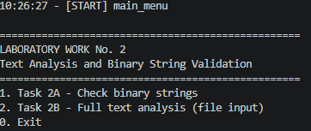
Скриншот 1. Запуск программы

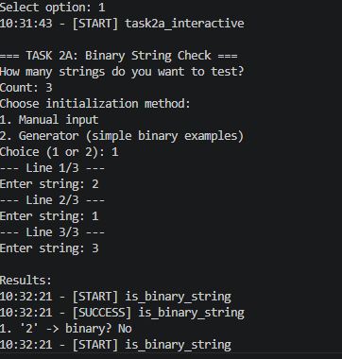
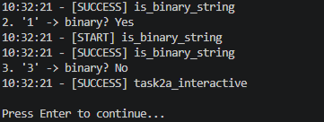
Скриншот 2-3. Выбор опции №1 – проверка N строк на бинарность

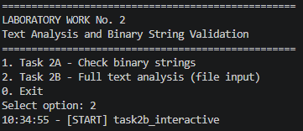

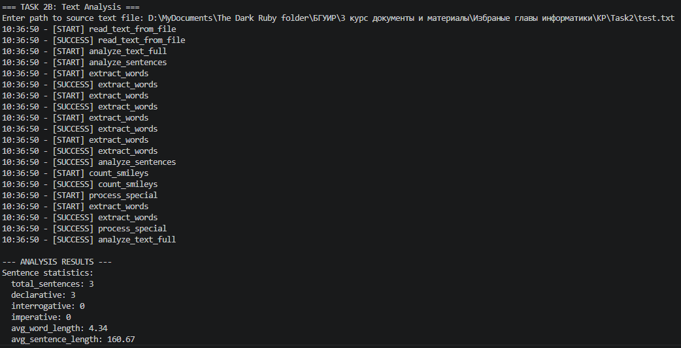
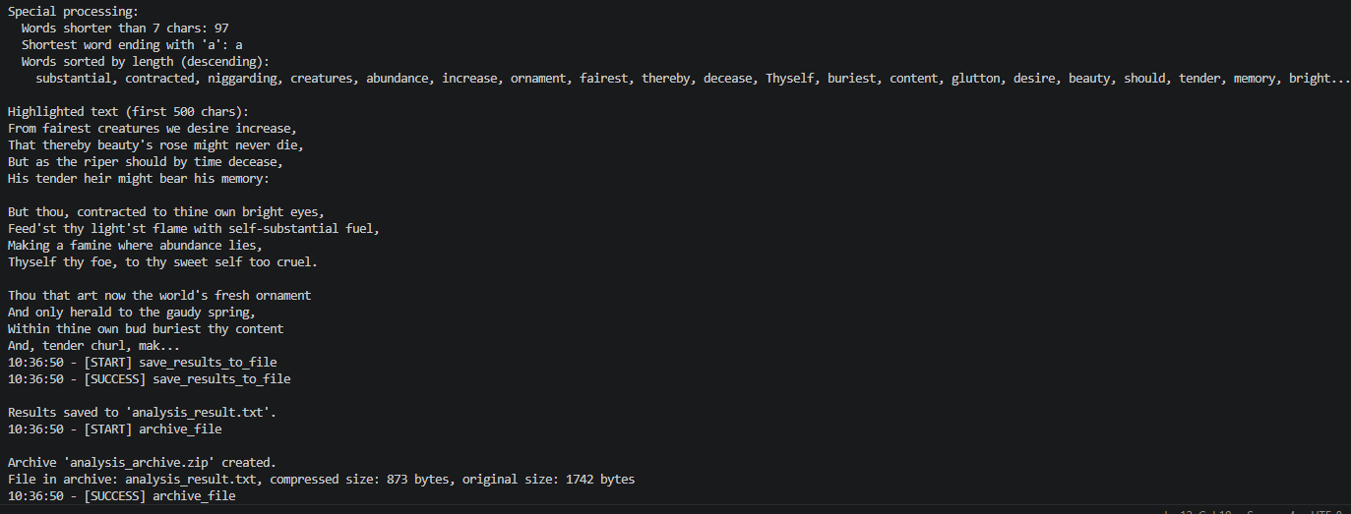
Скриншот 4-6. Выбор опции №2 – Анализ текста с последующей архивацией результатов анализа

